

**CIS 11042 – Practical for Essential of ICT and PC Applications**

**Information And Communication Technology**

**Faculty of Technology** **South Eastern University of Sri Lanka**

**Reg. Number:** SEU/IS/22/ICT/075

**Academic Year:** 22/23

**Practical Number:** Lab Sheet 19

**Title:** Installation of different Operating Systems (Ubuntu 20.04 LTS) using virtual machine

**Aims:**

• Getting practice to install Ubuntu 20.04 LTS and working with Ubuntu

**Tasks:**

1. Create a new virtual machine to install Ubuntu 20.04 LTS.
2. Install Ubuntu 20.04 LTS as a guest operating system on the host PC.

Exercise:

* 1. Open VirtualBox application 🡪 click on New🡪 Enter a virtual machine os name and select the OS type as “Linux” and version as “Ubuntu (64-bit)”Next → Set RAM to “4096 MB” → Next → Choose “Create a virtual hard disk now” → Create → Select VDI (VirtualBox Disk Image) → Next → Choose “Dynamically allocated” → Click Next → Set disk size to 25 GB → Create

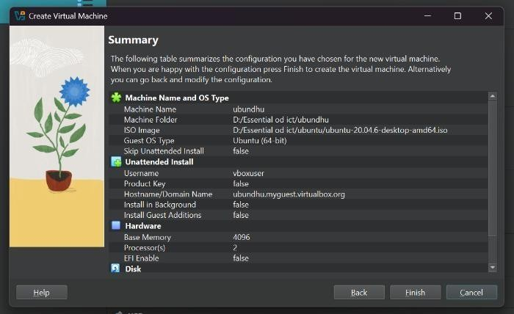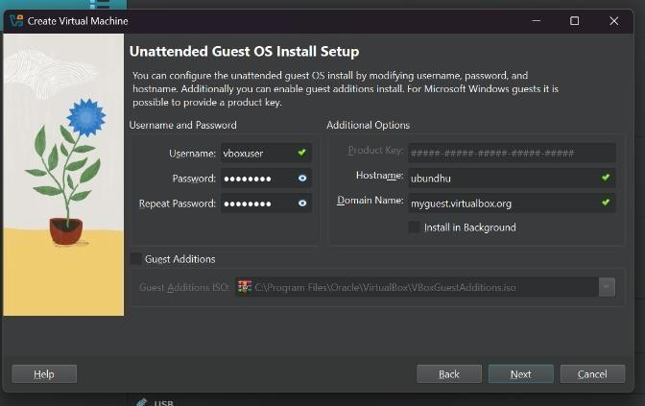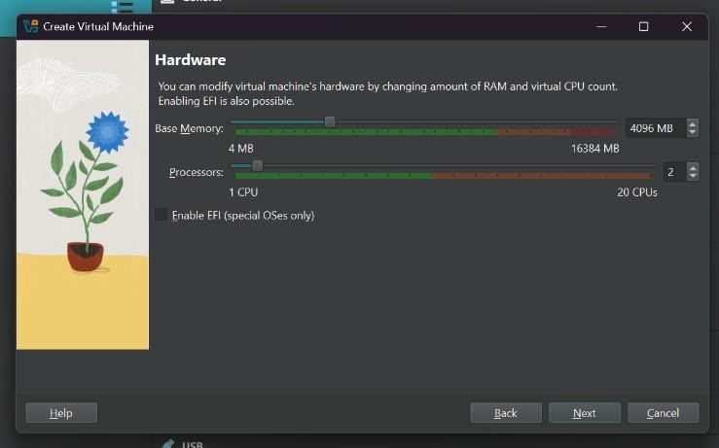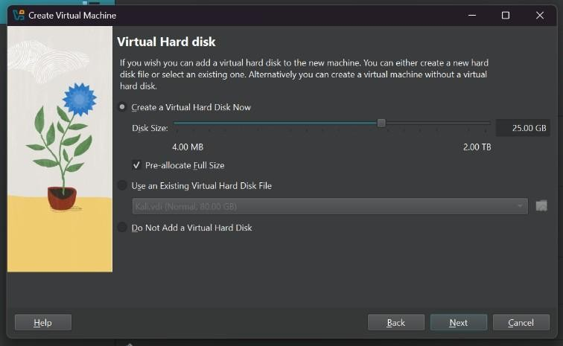

* 1. Start → Install Ubuntu → Continue → Set keyboard layout as “English (US)” → Continue

→ Selected “Normal installation”, ticked both options → Continue → Something else → Continue

Partitioned disk as follows:

2048 MB for swap (use as: swap area) → 12288 MB for “/” → 1024 MB for “/boot” → 6144 MB for “/var” → 18432 MB for “/home” (all as Ext4)

Install Now→ Confirmed changes → Set time zone as “Colombo” →Continue → Enter username and password → Continue → System restarted after installation

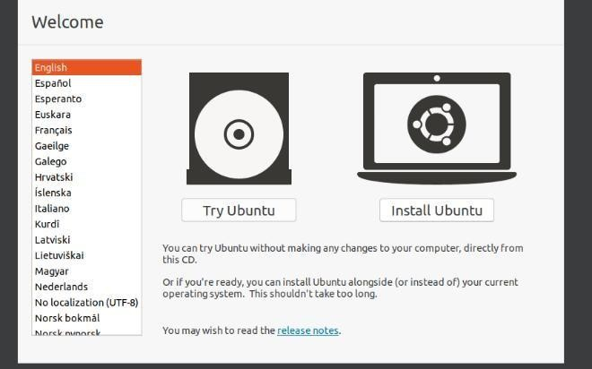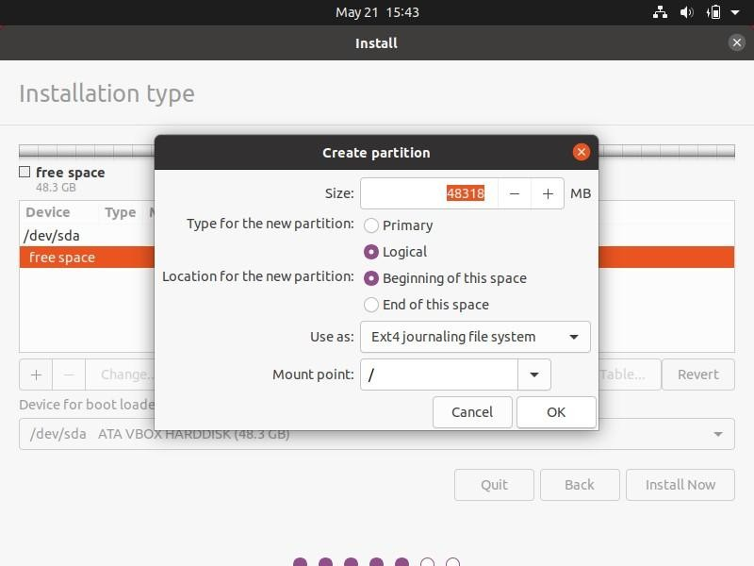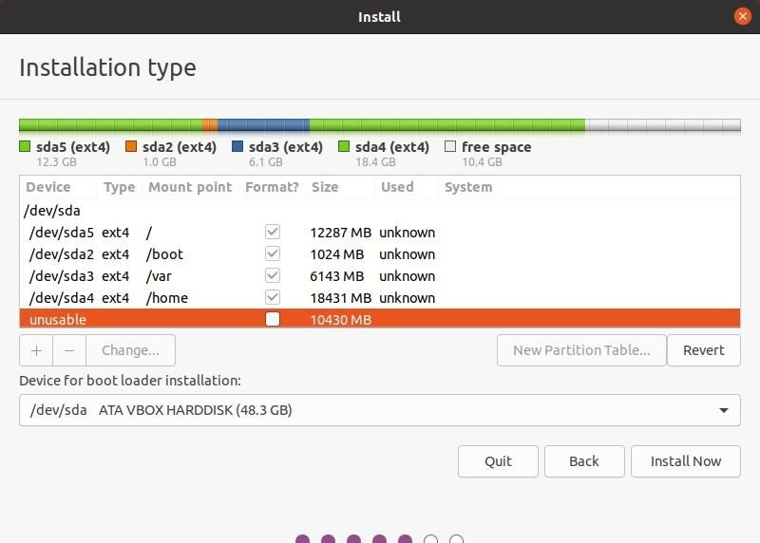

1. /- The main root folder where everything starts.

* + - /bin - Important programs you can run, like commands.

* + - /boot - Files needed to start (boot) the computer.

* + - /etc - Configuration files to set up the system.

* + - /var - Files that change a lot, like logs and emails.

* + - /swap - Space on the hard drive used like extra memory (RAM).

**Discussion:**

* Creating bootable USB in Ubuntu To make a bootable USB in Ubuntu:
  1. Plug in a USB drive.
  2. Open **Startup Disk Creator**.
  3. Download and select the Ubuntu ISO file.
  4. Click on **"Make Startup Disk"**.

* Ubuntu Desktop/Client and Ubuntu Server
* **Ubuntu Desktop :**

Ubuntu desktop have a desktop environment like kde ,xfce but difficultly it comes with gnome.

* **Ubuntu Server:**

No graphical interface. It’s used for running websites, servers, and services. It’s lighter and more powerful for server tasks.